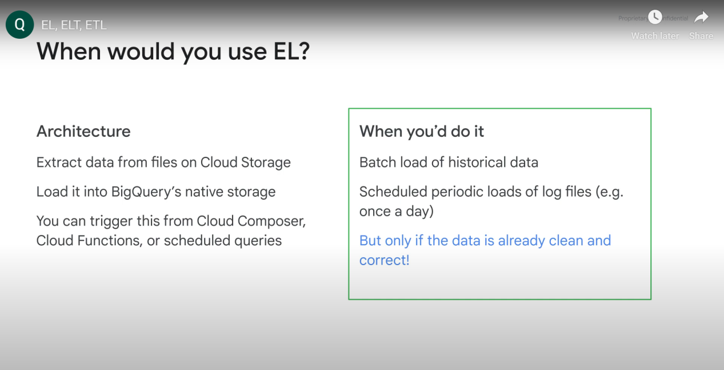

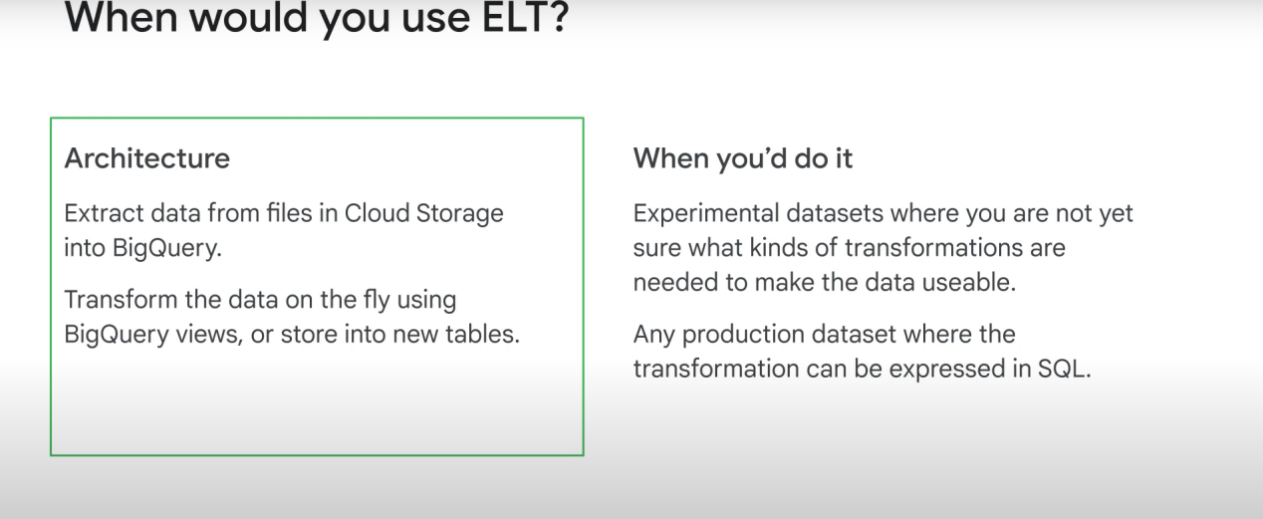

When to use ETL:

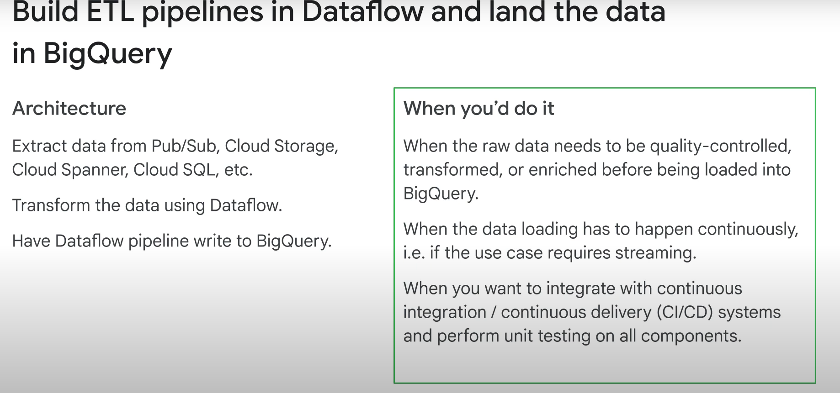

ETL can be used for this situation:

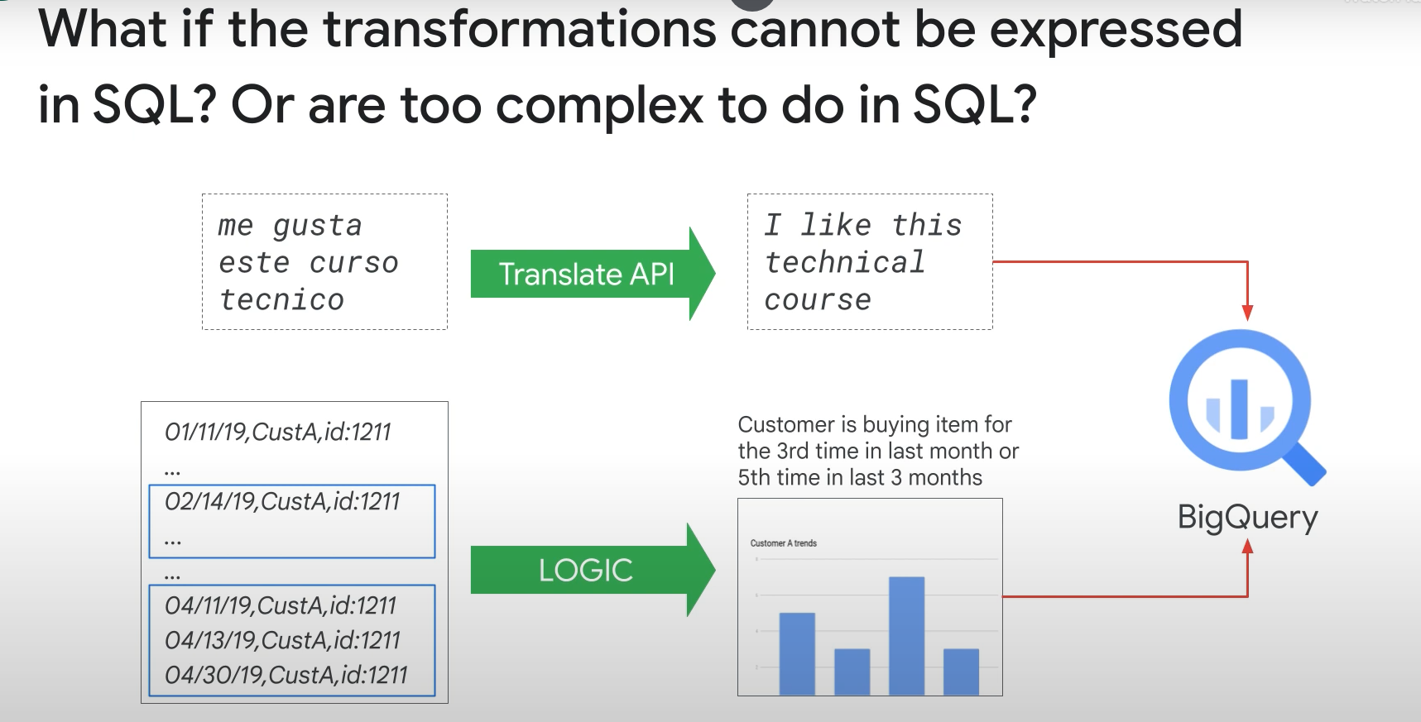

ETL TOOLS:

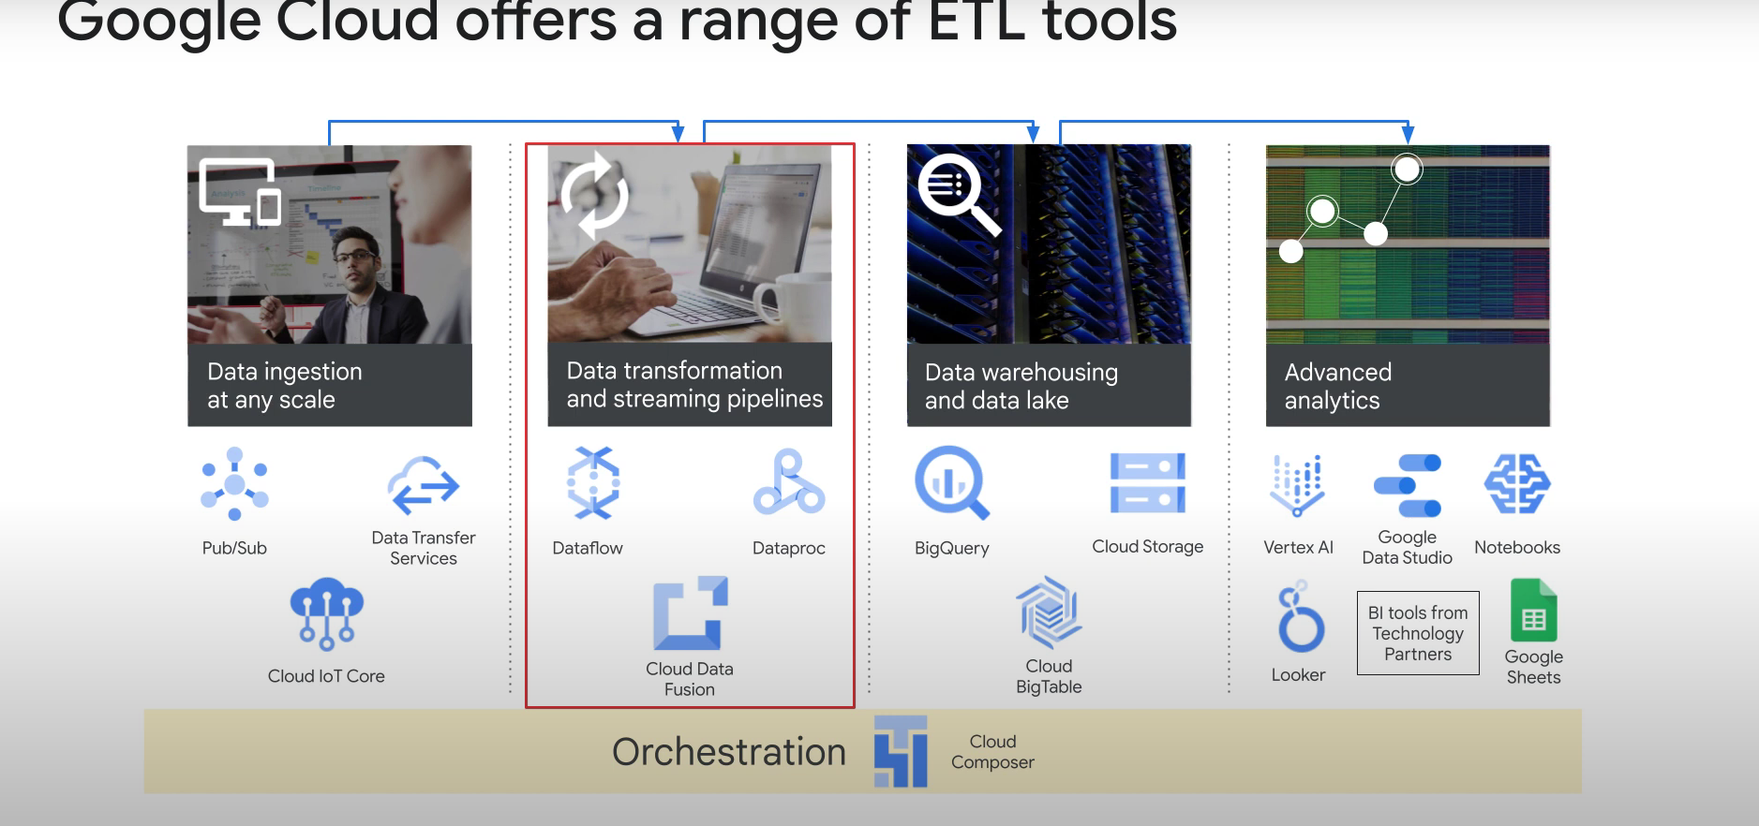

**Data proc:** requires significant hadoop expertise

**Datafusion**: provides simple UI to build ETL pipelines than can be deployed to data proc clusters

**Dataflow:** Batch + streaming data pipelines. Apache beans experience is good to have, but google also provides quick start templates for dataflow which makes it easy to use.

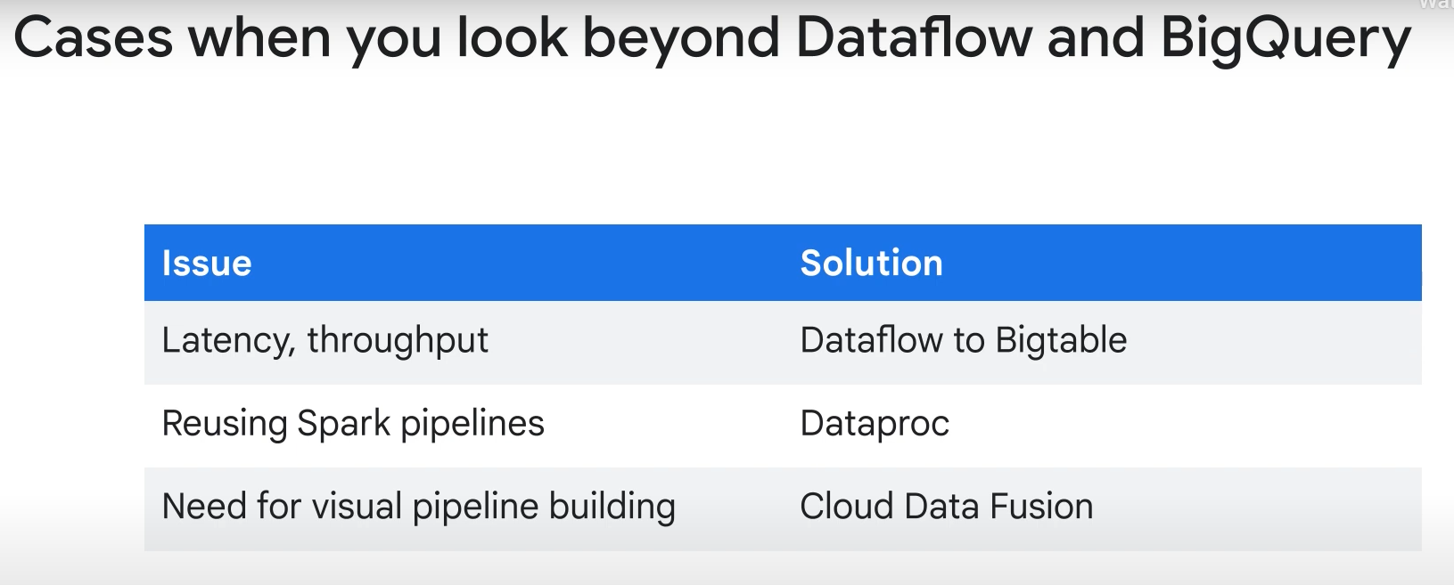

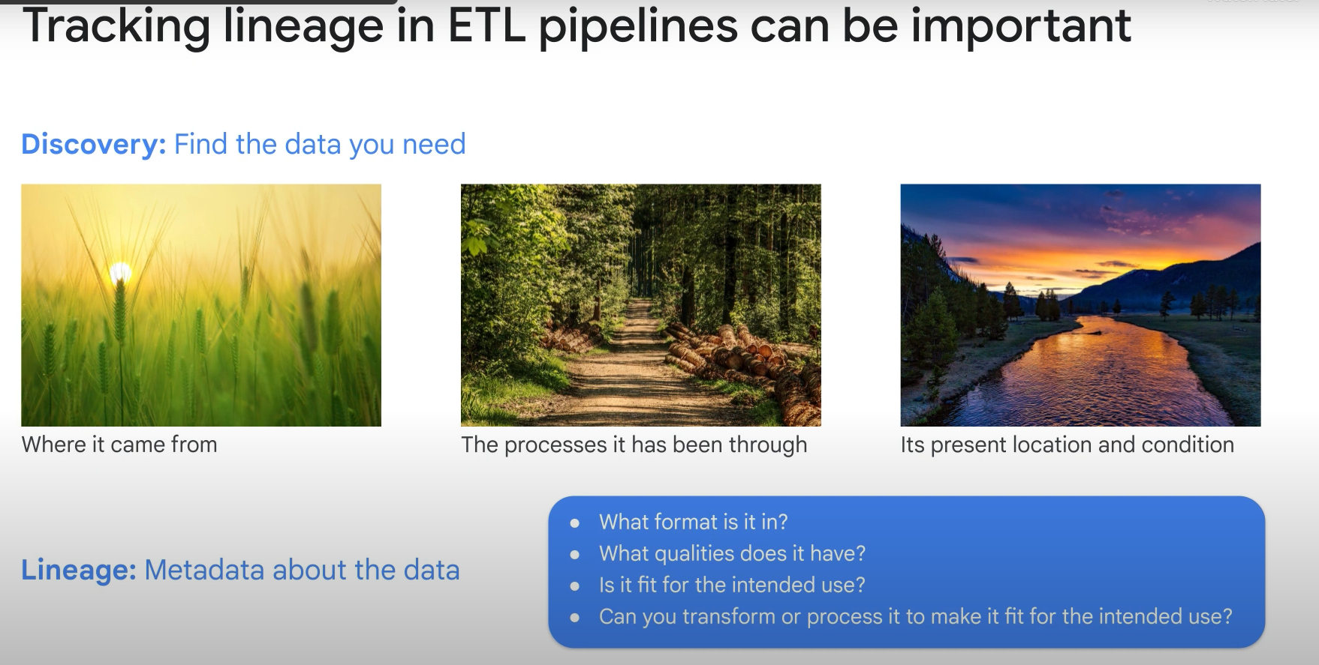

Data catalog allows you to see metadata (labels)/ lineage. It’s sort of a metadata as a service thing. It also allows to do data discovery.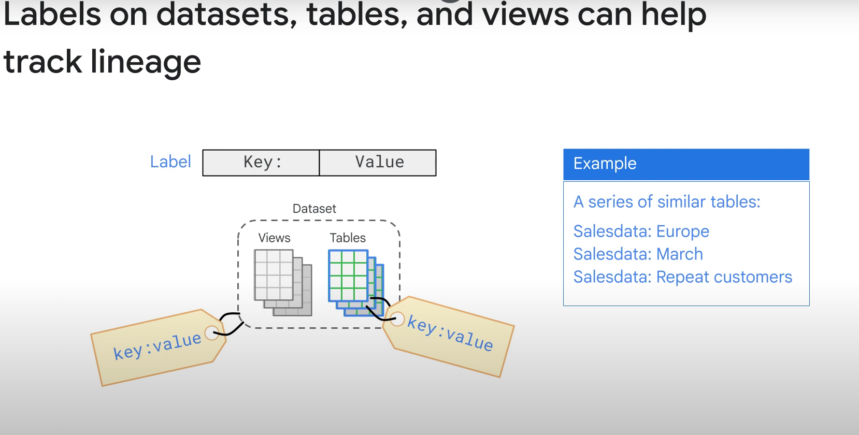

You can add labels to datasets, tables, and views

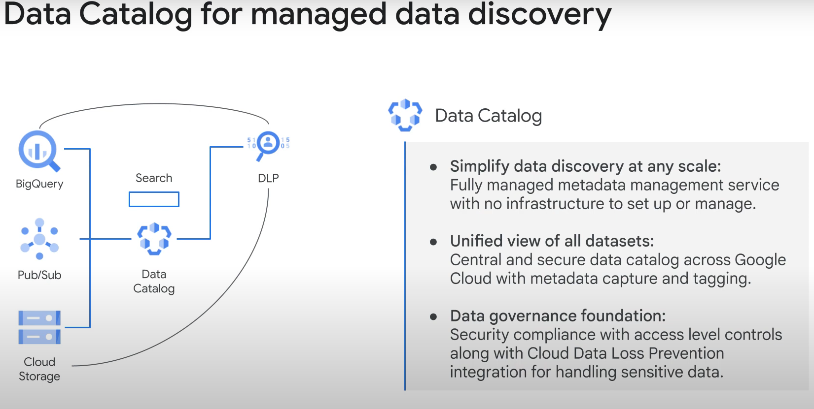

------------------------------------------------------------------------------------------------------------------------

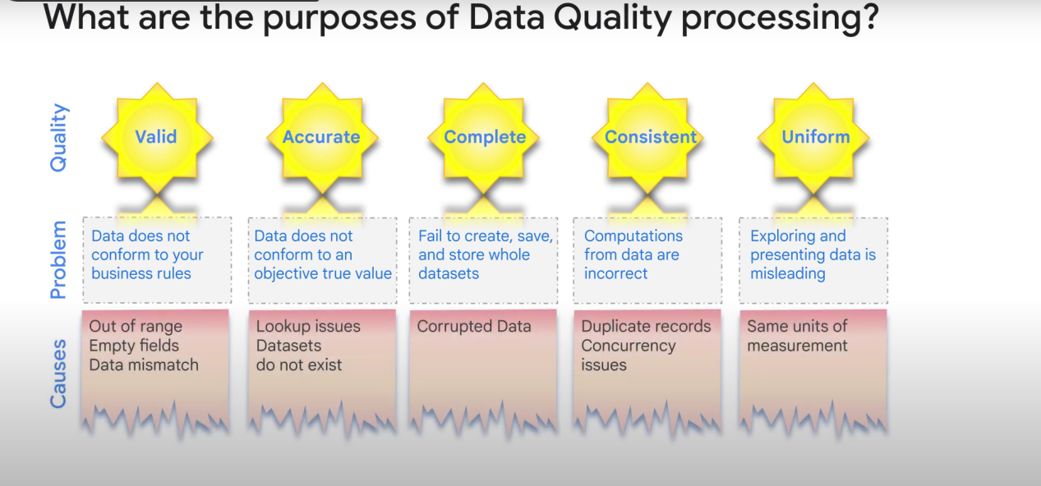

HOW TO FIX THEM?

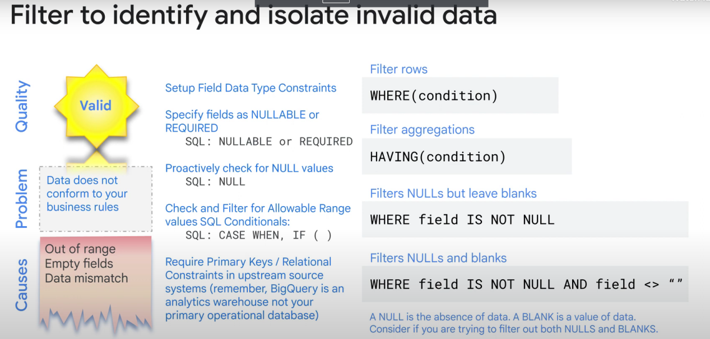

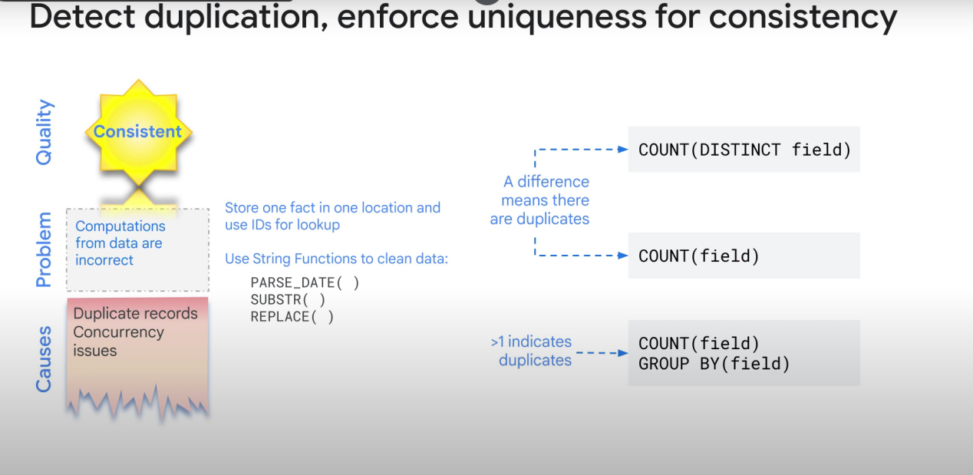

(duplicates, etc...)

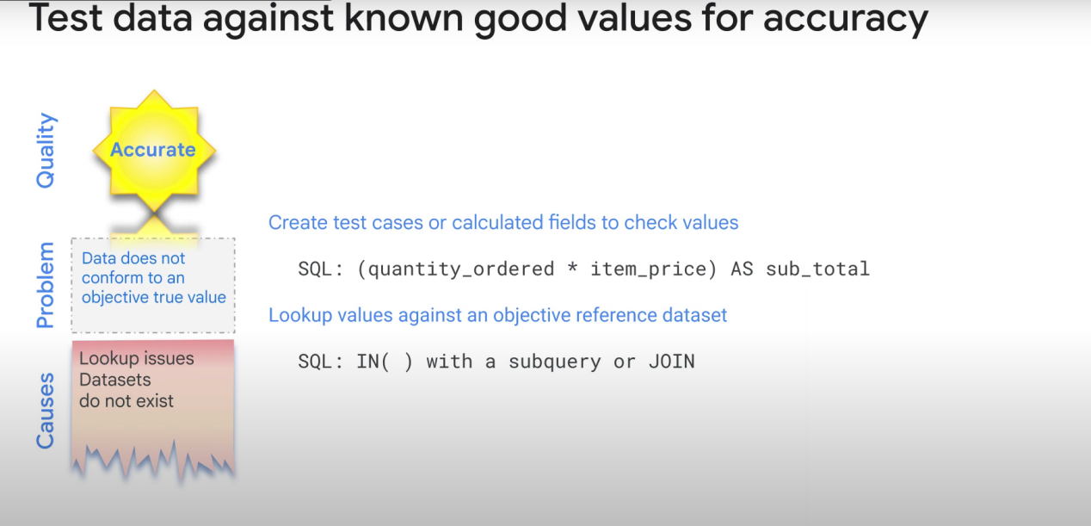

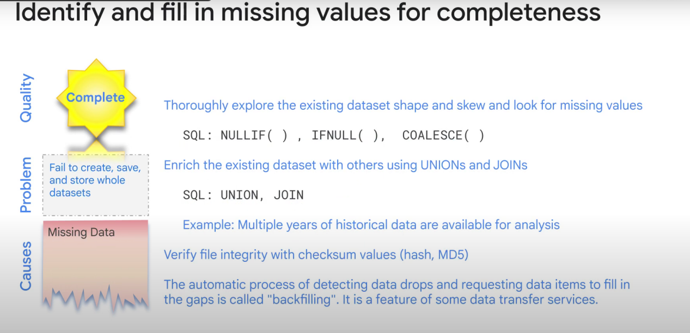

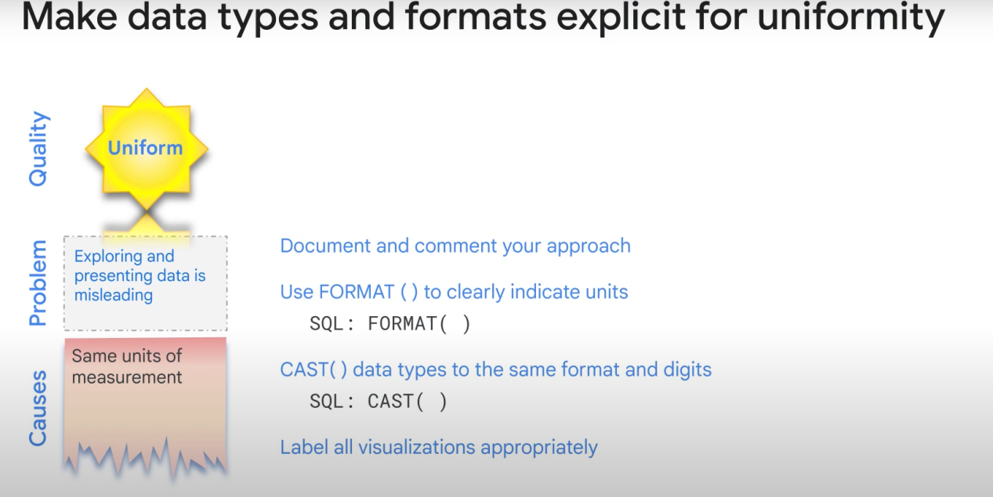

(Not using the same units, etc...)